**Annotation and filtering workflow**

The workflow below shows all of the files and steps for the annotation and filtering process that we will perform today. Use this workflow to navigate the process, monitor your progress and learn how the data is annotated and filtered into a short list of potentially pathogenic variants.

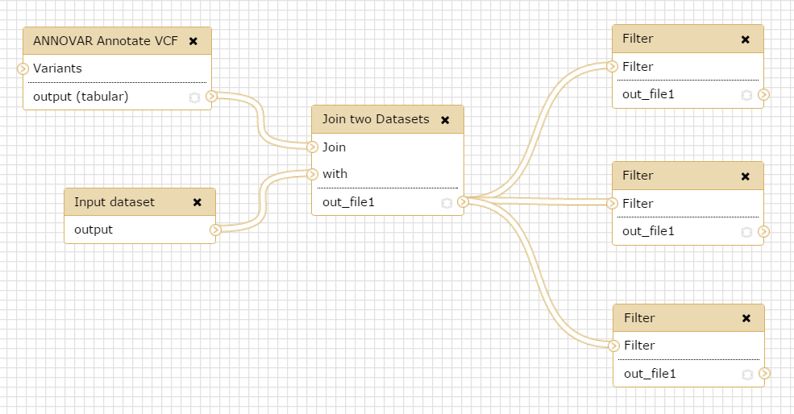

Filter VCF for:

Exonic

Not in public databases

Within candidate genes

Filter VCF for: Exonic

Filter VCF for:

Exonic

Not in public databases

Cross reference VCF with candidate

gene list

List of candidate genes

ANNOVAR annotate VCF